Cultural changes 1

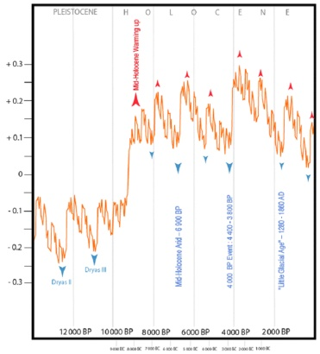 |  | This curve shows the differences (%) in modelled solar-output (luminosity) from 90.000-year average (from Perry & Hsü 2000). Warm-up periods in the Northern Hemisphere correspond to Humid phases in the Sahara, and European Glacial Ages correspond to SaharaAarids.  The three major Saharan Arid episodes are clearly visible (in blue).  The last two European Glaciations (Dryas II and III) match the hyperarid period beginning in the Sahara after the Aterian and going on till the beginning of the Holocene (conventionally established at 10.000 BP).
 | 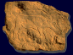
ROCK ART AND HUMAN ADAPTION TO CLIMATIC CHANGES IN THE CENTRAL SAHARA DURING THE HOLOCENE

HOLOCENEHOLOCENE

Cultural changes 2

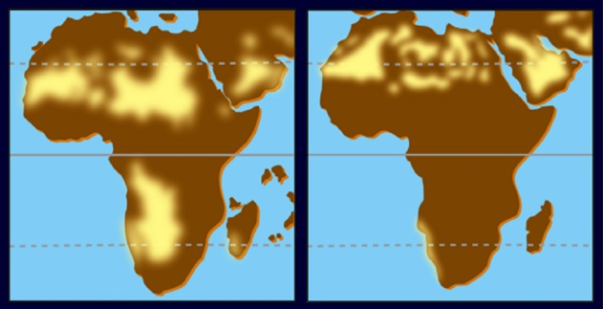
During this hyperarid period, the limits of the Sahara moved several hundred kilometres south, and the whole zone has been completely deserted for several millenia, because the Sahara was then totally abiotic.
During this Aterian Hyperarid episode (left) drier climate and stronger winds created extensive sand dunes in Africa.
Right: present extension of the dunes.

Cultural changes 3

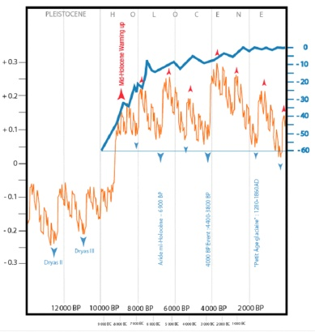 |  | After this very sad episod, an appreciable global warming occurred. The curve "jumps" around 8500 BP, and this "Holocene warming" favours human settlements in the Sahara: then begins the so-called "Climatic Optimum", and due to ice melting, rhe sea level raises significantly (here the blue line indicates sea-level variations in metres).

Cultural changes 4

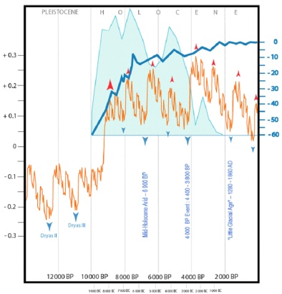 |  | The return of permanent rains increases the number of lakes in the whole Sahara. The most favourable life conditions occur around 8000 BP.  Here the diagram in flat pale blue indicates the differences in Holocene palaeolakes number (% from total for 10.000 years).

Cultural changes 5

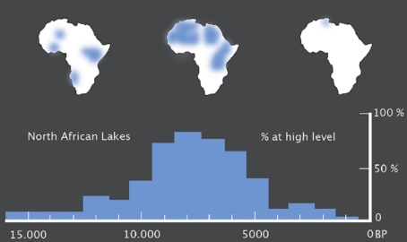
Without going as far as to say that "Climate makes History" (Hsü 2000), some important Human adaptations must have been regionally induced by shifts as important as the rapid warm-up which began at the Pleistocene/Holocene time boundary around 10.000 bp, as the Mid-Holocene Arid Period which dominated the Saharan climate around 6900 bp, or as the "4000 BP Event" which lasted from 4400 bp to 3800 bp and which correspond to the Post-Neolithic Arid Period in the Sahara. These important events, perceptible on a Worldwide scale, are shown by the solar-output variations, by the Sea-level fluctuations, and by the number of lakes in the Sahara. All these events are likely to have prompted, or at least encouraged, significant movements of population.

Cultural changes 6

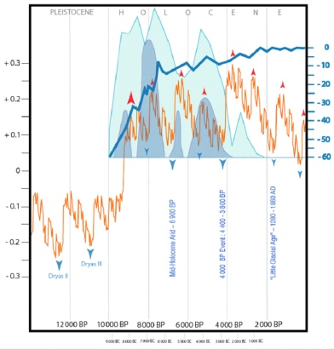 |  | In Libyan, the general trend is confirmed by the evolution of water levels in the Jerma Playa (flat dark blue). A short arid episod arises around 6900 BP, then a rain season became established. A tendency for increasing aridity can be seen around 5000 BP, which provoqued the collapse of some shelters here, some landslides there, and became tragic around 4000 BP (end of regular rains, drying of lakes, fast disappearing of permanent waterholes).

Cultural changes 7

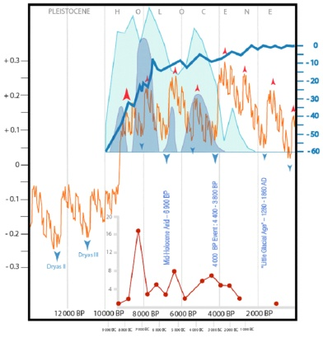 |  | From the beginning of the Climatic Optimum, some groups of Neolithic hunter-gatherers arrived in the old abandoned zones of the Central Sahara and took advantage of the restored environment. This is shown, for example, by the number of 14C dates obtained for anthropic levels in the shelters of the Akâkűs range in Libya (as shown here by the red dots, after Cremaschi & Zerboni 2003).

Cultural changes 8

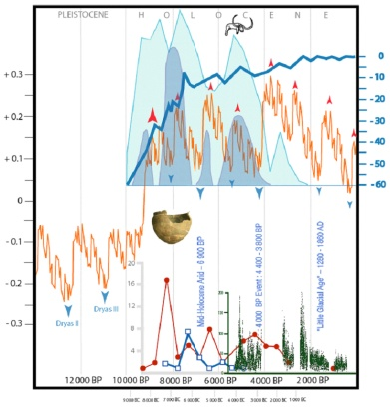 |  | From the beginning of the Climatic Optimum, some groups of Neolithic hunter-gatherers arrived in the old abandoned zones of the Central Sahara and took advantage of the restored environnment. obtained for anthropic levels in the shelters of the Akakus range in Libya (Cremaschi & Zerboni 2003).  Two millenia and half before the advent of ceramics in the Fertile Crescent around 8000 BP, some of these Saharan people were already carrying potteries which are among the oldest in the world -- the oldest ones being the Jômon potteries appearing in Japan at the end of the Peistocene

Cultural changes 9

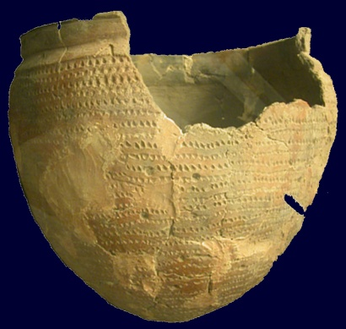 |  | In fact, the oldest Saharan potteries have been found in Niger and are certainly over 10.000 years old : from 10500 ą 780 BP to 9820 ą 780 BP at Tagalagal, and from 10500 ą 750 BP to 9530 ą 730 BP at Adrar Bous. Younger dates show the diffusion of this technique, first in Algeria in the Tassili (at Ti-n-Hanakaten: 9420 ą 200 BP) and the Tefedest n-Ahaggar (Abri Launay: 9210 ą 11 BP), then in the Akâkűs in Libya (Wa-n-Tabu : 8950 ą 55 BP, Wa-n-Afuda : 8790 ą 93 BP, Ti-n-Torha East : 8640 ą 70 BP) (Roset 1983, 1996-a, 1996-b; Mori 1998: 56).  Prehistoric pottery found  in the Akakus  (Tripoli, National Museum).

Cultural changes 10

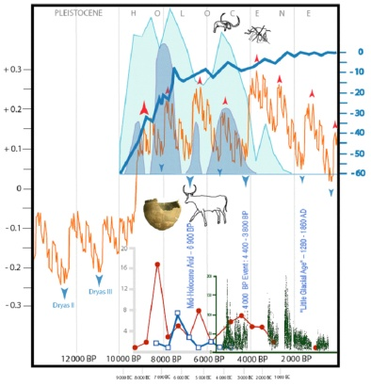 |  | The great African Fauna disappears ca. 4000 BP, and the Bovidian period cannot begin before the appearance of domestic bovids, never attested in Africa before the seventh millenium BP.  The first certain domestic bovids known in Egypt go back to 6400 BP in the Fayum, and to ca. 6000 BP at Merimde. In the Central Sahara, the most ancient domestic bovids have been discovered in the Akâkűs and date back to the VIe millenium bp: 5970 ą 50 bp in the upper levels at Ti-Torha North, and 6035 ą 100 bp in the middle levels at Wa-n-Muhuggiag.  Older dates (7430ą220 bp at Ti-n-Torha, 8100 bp at Nabta) are now abandoned (wrong identification at Ti-n-Torha, doubtful and not confirmed at Nabta).

Cultural changes 11

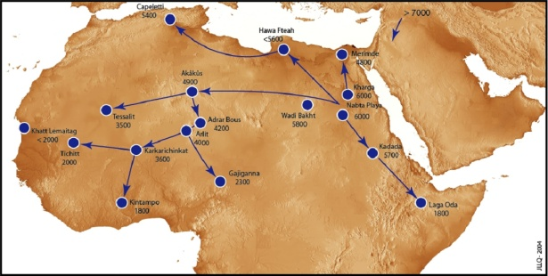
Progression of the domestication of the bovids in the Sahara
(dates BC)

Cultural changes 12

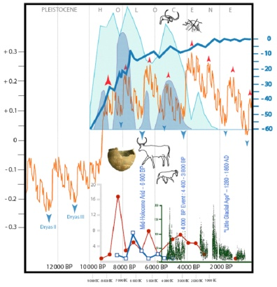 |  | The older ovids in the central Sahara have been found in the Akakus, at Wa-n-Muhjaj (6035 ą 100 bp) and Wa-n-Telokat (5900 ą 80 bp). Some older dates mentioned during the fifties (7438 ą 220 bp at Wa-n-Muhuggiag and 6745 ą 175 bp at Wa-n-Telokat) were erroneous. This means that sheep images, frequent in rock art of the Central Sahara, cannot predate the VIth millenium bp, as it is also the case for countless pictures of domestic bovids. A large majority of Saharan rock pictures having been made by herders, this means that the major flourishing period of this art must be placed in the VIth millenium or slightly later.

Cultural changes 13

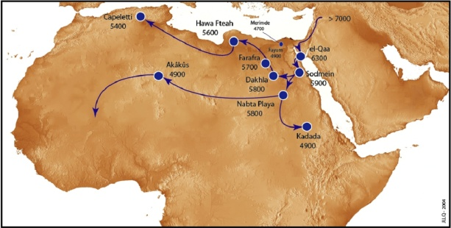
Domestic ovicaprids progression in the Sahara (dates BP). The shift from cattle farming to ovicaprid farming occured during the Late Pastoral, and probably corresponds to an adaptation to the growing aridity.

Cultural changes 14

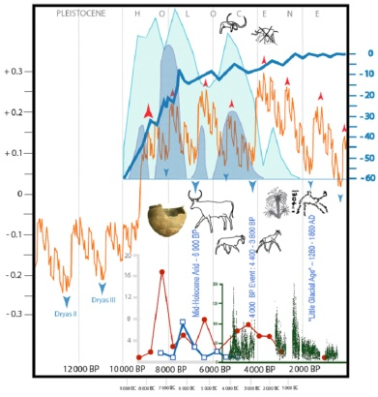 |  | During the IVth millenium bp, megalithism spreads throughout South Fezzân, and this movement coincide with a greater drying out. Large necropolises appear around 3000 bp, and mark the beginning of the Garamant Period. Life was still possible in the Central Sahara, provided people stayed in areas with available surface water (or with water near the surface). Offerings of stone dates in some tombs of the Wâdi Tanezzuft (South-West Fezzân) during the second half of the IVth millenium bp constitute an significant milestone in the history of the palm-tree (Phśnix dactylofera L.) in the Sahara.

Cultural changes 15

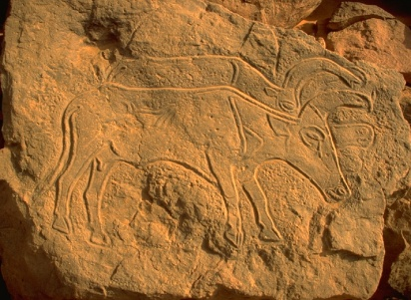 |  | In the Central Sahara, the onset of the Holocene Climatic Optimum coincides with the arrival of people who repopulated the territories abandoned since the Postaterian Hyperarid Period, and who made the first known pottery in the continent. After the Mid-Holocene Arid Period, the inhabitants of the Sahara shifted to cattle farming as long as the climate allowed it. They were nomads moving away from their main quarters to look for pasture during the humid season, going back to the massifs with their herds during the dry season.

Cultural changes 16

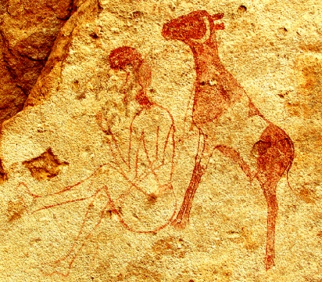 |  | When climatic conditions deteriorated significantly, they shifted from cattle to ovicaprid farming, as sheep and goats are much more adapted to the harsh environment where they had to live thereafter. This situation is easily understandable as ovicaprids are known for their capacity to content themselves with a minimum diet and to resist very arid environments.

Cultural changes 17

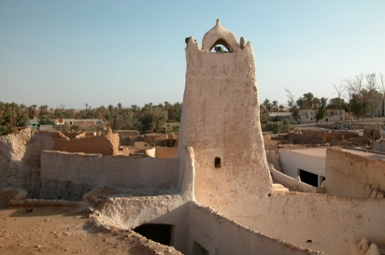 |  | Climate getting worse and worse, people had to settle progressively near the places where water was still available or easily accessible. Then grew the Garamantic civilization, mostly in these places of the Wâdi el-Ajâl where the foggârât made it possible to irrigate, hence to cultivate in an hyperarid environment. Settlement, cultivation and reduction of the living space correspond to the latest adaptative phase to the regional dessication. Citadels, monumental tombs and necropolises grew in number, and the whole situation began to prefigure the present oasis and their way of life based on the trans-Saharan traffic.

Cultural changes 18

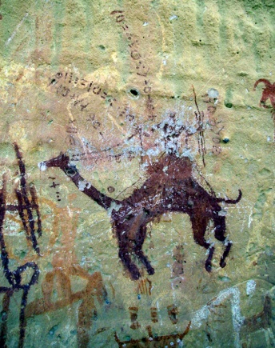 |  | The current image of the Saharan life was coined at that time, particularly with the introduction of the palm-tree (an element essential for life in the oasis) during the second half of the IVth millenium bp.  Around the beginning of the Common Era, the newly introduced dromedary allowed Saharan people to fully recover the Sahara and to retain control of this huge territory, till modernity lately changed the rules of the game.

Cultural changes 19

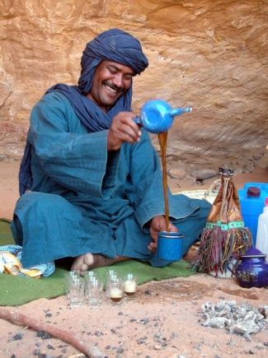 |  | Now, pretending to free oneself from the climatic laws, modern man uses the most recent techniques  financed by the oil manna  to shape a large part of the Sahara just as he whishes. Systematic exploitation of fossil water allows a seeming improvement of the landscapes, which artificially grow green again, particularly in Fezzân. Now it could be appropriate to meditate Garamants' posthumous lesson: thanks to the foggârât technique, they overexploited the Fezzanese Sahara, and built a powerful State but their needs soon exceeded the renewing capacities of their natural resources, and they were bound to disappear.

Astronomical factors 1

 | Climate change mechanisms  Mechanical, thermodynamical, biological and human factors combined through times to bring about the climatic changes whose main result is the present Saharan aridity.  The most important of these factors are those stated by Milutin Milankovitch in his "astronomical theory" (Milankovitch 1920, 1941). This Serbian mathematician stated that, at a planetary scale, temporal and geographical climate variations are linked to insolation, which fluctuates according to the position of the Earth to the Sun. The succession of the seasons is caused by the angle of the polar axis and by the annual ecliptic revolution, but the general succession of the glacial and interglacial periods (corresponding to arid and humid periods in the Sahara) positioned at much more considerable intervals, is caused by what could be called "astronomical seasons" linked to three main factors:  1 -variation in the eccentricity of the Earth orbit,  2 -variation of the obliquity,  3 -precession of the equinox. | 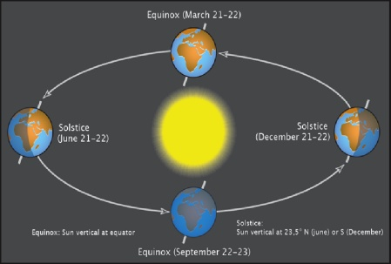
 |  | The tilt of Earth's axis in its annual orbit around the Sun causes the Northern and Southern hemispheres to lean directly toward and then away from the Sun at different times of the year.

Astronomical factors 2

1 - Variation of the obliquity
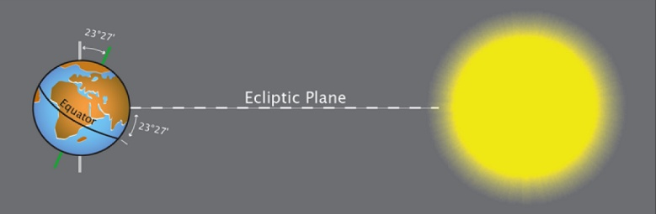
The Earth revolves around the Sun in a plane called "ecliptic plane", and the polar axis forms an angle of 23°27' to this plane.

Astronomical factors 3

 | 2 - Precession of the Equinoxes | 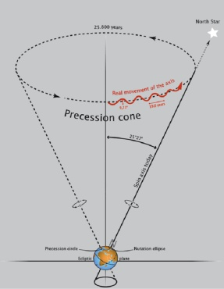
Now, these two factors are not constant, and due to Moon's and Sun's attraction, the polar axis slowly describes a cone, following a movement called "astronomical precession".
In addition to its rapid (daily) rotational spin and its slower (yearly) revolution around the Sun,
Earth wobbles slowly like a top, with a full wobble every 25.700 years.

Astronomical factors 4

 | 3 - Variation in the excentricity | 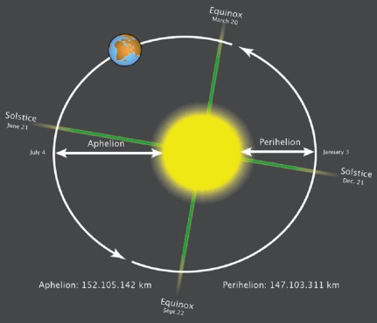
This obliquity and the fact that the Earth describes an elliptic (and not circular) orbit have an influence on the interception of Sun's radiation by the Earth, a fact which explains that seasons do exist.
Earths orbit around the Sun is slightly elliptical. Aphelion is currently reached on July 5, and Perihelion on January.

Astronomical factors 5

 | 3 - Variation in the excentricity | 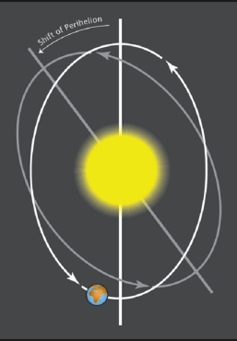
Seasonal climatic variability is affected by precession,which changes the date at which the Earth reaches its perihelion (closest place to the sun).
If perihelion is reached in winter (currently on January 3), seasonal differences in insolation are reduced in the Northern hemisphere because this Hemisphere is closer to the Sun.

The elliptical shape of Earths orbit
slowly precesses in space, so that
the major and minor axes of the
ellipse slowly swift through time.

Astronomical factors 6

 | 3 - Variation in the excentricity | 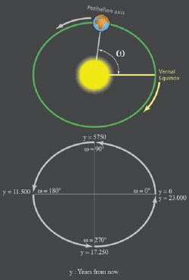
Aphelion (most distant place to the Sun) is currently reached by the Earh on July 5, and the Northern summer is relatively cooler because the Earth is further away from the Sun.
The reverse was true 11500 years ago, because the Earth then reached its perihelion during the Northern summer.

The angle w between lines marking Earths perihelion axis and the vernal equinox (March 20) increases from 0° to 360° each full 23.000-year cycle of precession.

Astronomical factors 7

Earths wobble and the slow turning of the elliptical orbit combine to produce the precession of the equinoxes. Both the solstices and the equinoxes move slowly around the excentric orbit in cycles that take 23.000 years. | 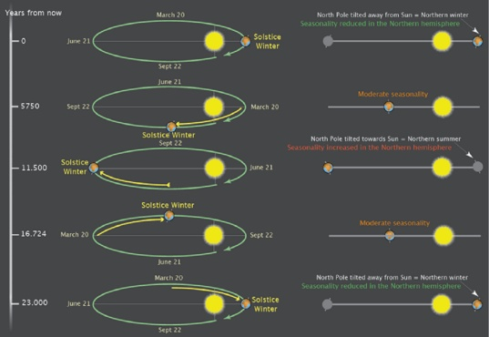

Astronomical factors 8

These three major variations (excentricity, obliquity, precession) cause the main variations in Earth's insolation. Each one has its own particular periodicity:  1 - Excentricity varies according to 100.000 and 413.000 year cycles, |  | 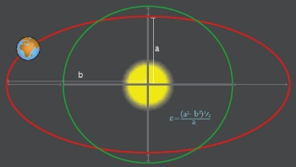
 | 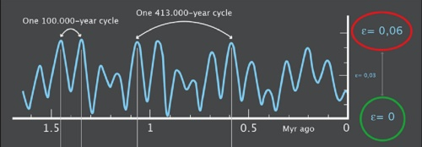

Astronomical factors 9

2 - Obliquity varies according to a 41.000 year cycle | 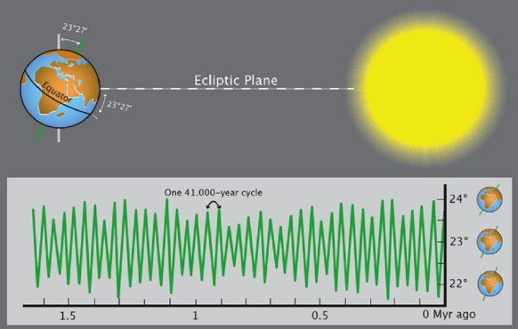

Astronomical factors 10

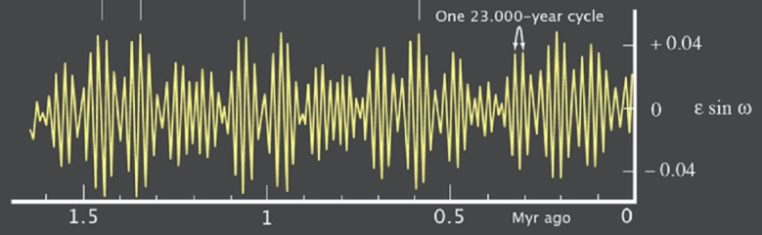
3 - and the precessional index changes mainly at cycles of 23.000 years.
The amplitude of this cycle is modulated at the excentricity periods of 100.000 and 413.000 years.

Astronomical factors 11

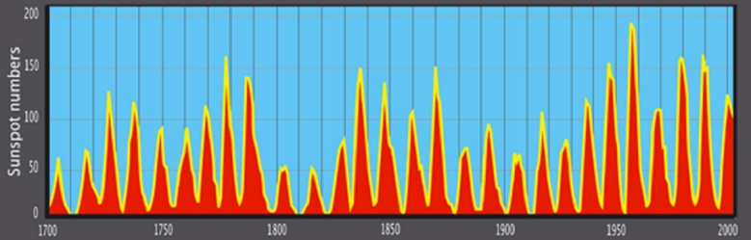
Solar activity varies according to 11 and 90.000 year cycles

Astronomical factors 12

 | The resultant of all these variables is a curve evolving like the global variations of the Earth's climate. Seasonal insolation changes at 65° in the northern and southern hemispheres look different because the phase of the precession cycle is reversed between hemispheres. | 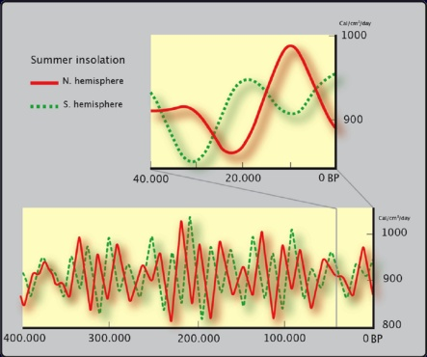

Astronomical factors 13

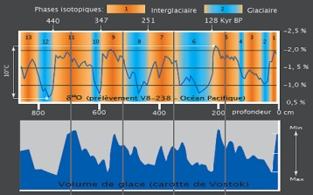 |  |  | 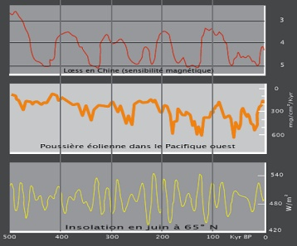
 | The validity of the global climatic curve integrating all these variables has been checked for several hundreds of thousands years, by means of comparisons with many other curves showing, at thesame scale, the periodicity of other variables (atmospheric CO2 and methane concentrations, levels of oxygene isotopes in water, lacustrine and marine sedimentations, etc.)

Astronomical factors 14

 | Here is the part of this curve showing variations in solar output during the last 14.000 years  (the most interesting period for rock art studies).  Differences (%) in modelled solar-output (luminosity) from 90.000-year average  (from Perry and Hsü 2000, modified). | 